HOW JAVASCRIPT WORKS BEHIND THE SCENES

Javascript internally works as a synchroneous single threaded language that means it executes code line by line and only one command at a time, means JS only handles one task at a time justifying its single threaded nature and it runs code line by line (synchroneous), each line must completed its execution so that JS can move to the next line and so on.

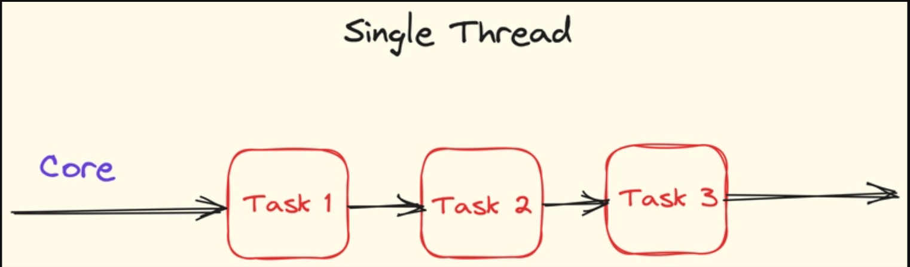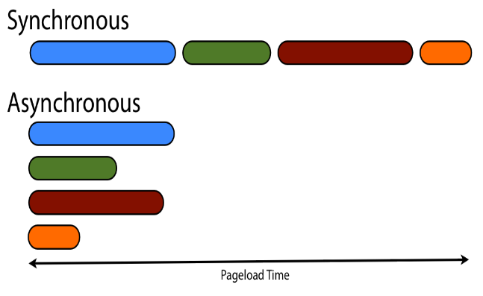

How js engine handles code execution –
When JS engine executes a piece of code, it breaks down the code into small tokens, then it first parses it, then it converts it into Abstract Syntax Tree (AST), which is hierarchical structure of ur code, then in compilation phase it converts that into machine readable bytecode, using JIT (just in time compiler) , JIT watches for frequently running function, it consider it as a “hot code”, it compiles that hot code for improving performance and then finally the machine gets executed line by line.

Execution Context
Everything in Javascript happens inside the execution context, when we first run a program, the Global Execution context gets created and pushed into the callstack, the execution context has two components, a memory (also known as variable environment) and code component (also known as Thread of execution), memory component is responsible for memory assignments like if a code has defined a variable a with 10, then in memory assignment phase the variable is undefined and stays in TDZ till code execution phase awakes or if we assigned that variable a value in our code then that value got assigned to that variable in code execution phase.
Execution Context
let a = 10;
function sum(){
let b = 15;
console.log(a + b);
}
Memory Creation | Code Execution
let a; [TDZ]  function sum{} | a = 10  Memory Creation Code Execution  let b = undefined//TDZ b = 15 clg(a + b) //25

